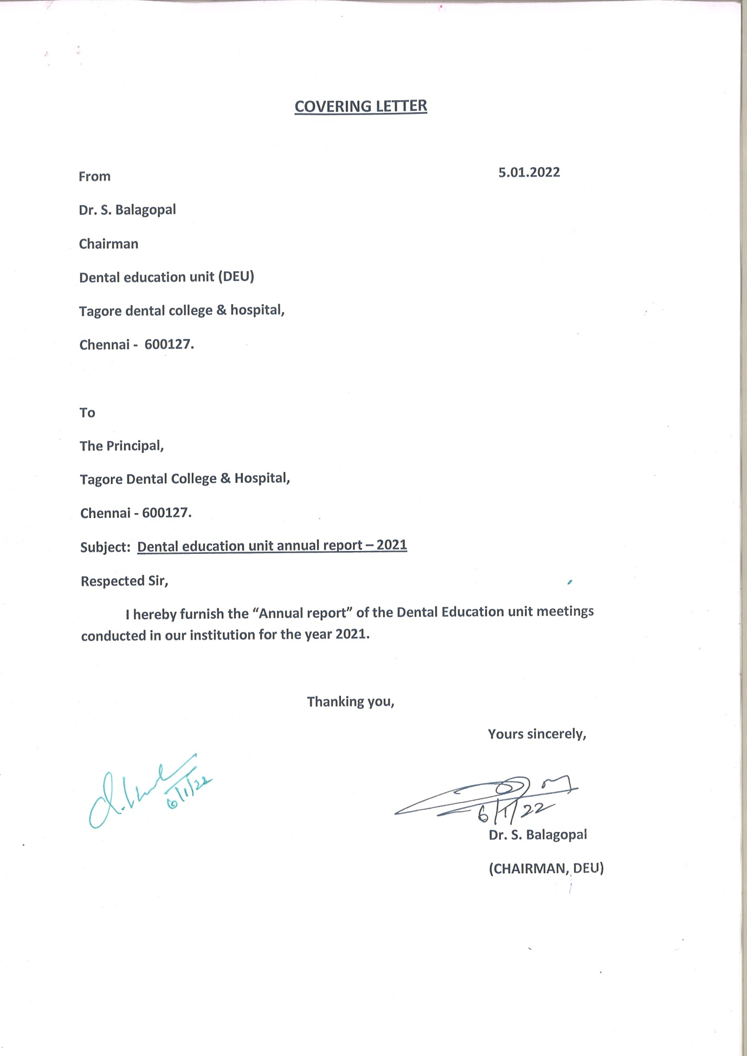

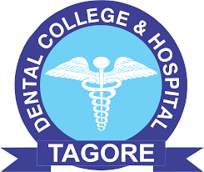

TAGORE DENTAL COLLEGE & HOSPITAL
DENTAL EDUCATION UNIT
ANNUAL REPORT – 2021

THE COMMITTEE MEMBERS:

- Dr.S.Balagopal
Vice- Principal
Prof& HOD Dept of Conservative Dentistry & Endodontics
- Dr. Vandana James
Reader, Dept of Conservative Dentistry & Endodontics
- Dr. L.S.Makesh Raj
Reader, Dept of Oral pathology
- Dr. Narasimman
Reader,Dept of Prosthodontics
- Dr. Priyadarshni.R
Reader, Dept of Periodontics
- Dr. Mahalakshmi
Senior Lecturer, Dept of Orthodontics
- Dr.Parvathi
Senior Lecturer, Dept of Oral medicine
- Dr.Israel
Senior Lecturer, Dept of oral surgery
- Dr.Charanya
Senior Lecturer, Dept of Conservative Dentistry & Endodontics
10) Dr. Sarath Kumar
Senior Lecturer, Dept of Conservative Dentistry & Endodontics

DATES OF MEETING
Meeting of the dental education unit & curriculum committee for the year 2021 were conducted on following dates:
- 19th JANUARY 2021
- 22nd JUNE 2021
- 23rd SEPTEMBER 2021
- 30th DECEMBER (Meeting not conducted due to examination duties for the members as external and internal examiners for various institutions.)

ACTION TAKEN FROM PREVIOUS MEETING

PGs and CRRIs were asked to come to college along with their COVID 19 negative report in order to join the college as per the instructions issued by the Director of Medical Education (DME), Chennai.
As per DME instructions all the UG and PG students submitted the test report to college office. The CRRIs were attending the college on alternative days and PGs attending regularly for the first few months and regularly from September onwards. PGs and UGs were following the following the SOP for the safe and smooth functioning of patient treatment.
Following the recommendations from the previous DEU meeting PGs were provided with autoclave apron and PPE kit, considering the COVID 19 safety protocols. Survey was also conducted among the students regarding opinion about the practical sessions and patient work.

Discussions for academic year 2021:
Elective dental procedures were only handled and treated by the faculty and PGs with utmost care and safety measures. Strict sterilization was followed and patients were advised to minimize the attenders accompanying them to prevent crowding and maintain social distance.
Infection and prevention control (IPC) practices for routine dental health care delivery were providing during lockdown period. Postgraduates and CRRIs were instructed to present their journal discussion, seminars through online/google meet through their mentors.
Education 4.0 was discussed with suggestions to implement the protocol in Tagore dental college and hospital. It emphasized the need to prepare students to take on challenges head-on. To keep up with the change i.e., to get accustomed to the shift from traditional educational paradigms towards futuristic approach of learning.
Salient features discussed about Education 4.0 included
- Mainstream technology enhanced education with learning experience.
- Setting Education 4.0 at Tagore dental college with country level standard and priorities.
- Psychomotor skill development associated to Education 4.0

- As per the recommendations from the members in the previous DEU meeting the postgraduate students were provided with PPE kits and autoclave gowns, face shield.
- Standard SOP is being followed by the postgraduates and staffs as per the instructions of the Director of medical education (DME) for the smooth functioning of patient treatment.
- The programs planned and conducted by various departments were also reviewed.

Safety protocols and awareness about pandemic were instructed among the teaching and non-teaching, faculty ,PGs, CRRIs and UGs student.50% CRRIs and students were attending college with strict and safety protocols and RT-PCR negative report for COVID-19. As of now all are attending the college and PGs are attending regularly. Dental Education Unit and Curriculum Committee organized TAGORE ACADEMIC FEST 2021.
The model exam was conducted successfully in each department which was followed by final exams theory as well as practical exams for the clinical departments.

INTERDISCIPLINARY PROGRAMS :

Interdisciplinary courses for the postgraduates were conducted in various departments. A report with detailed summary along with photographs have been collected and filed.

- Development and delivery of E-courses were done due to the prevailing COVID-19 pandemic for facilitating the students to learn without any issues.
- Online classes were conducted and monitored via Google meet (online classrooms).
- All the departments conducted CDE programs.
- Every department conducted 2 guest lectures.
- All the departments were encouraged to conduct advanced teaching techniques/ innovative teaching and learning methods for the students of Tagore dental college and hospital.
- Psychomotor skill development using various exercises were also suggested and conducted as a part of advanced teaching techniques/ innovative teaching and learning methods such as Small group discussions, Peer assisted learning, Jig saw puzzles, Participatory learning, Flash cards and Project based learning.
- The Department of Conservative Dentistry & Endodontics is conducting a 30 hours certificate course on “Isolation techniques” for the interns (ongoing).
- Department of periodontics conducted and interdisciplinary program for the postgraduate students of Tagore dental college and hospital on “lasers”.
- Department of orthodontics conducted a photography workshop as as apart of interdisciplinary programs.
- Periodic clinical society meetings are being held for the interns, postgraduates and staffs of Tagore dental college and hospital.
- Pre- clinical skill competition was also conducted for the students with exercises such as tooth carving, class II cavity preparation, class I teeth setting jointly by the department of prosthodontics, department of conservative dentistry and department of Oral & maxillofacial pathology.
- Approval for conducting a program on “Stainless steel crowns” from the department of Pedodontics was given.
- Approval for conducting a program on “Management of Endo-Perio lesion/Flap/Crown lengthening/Curettage etc. by the Department of Conservative dentistry and Endodontics & Department of Periodontics.

AMMENDMENTS IN THE COMMITTEE MEMBERS

The present members of dental education unit were revised in the second dental education unit are as follows:

- Dr.S.Balagopal,
Chairman, DEU
- Dr. Vandana James
Member Secretary
- Dr. L.S.Makesh Raj
Member, DEU
- Dr. Narasimman
Member, DEU
- Dr. Priyadarshni.R
Member , DEU
- Dr. Mahalakshmi
Member, DEU
- Dr.Parvathi
Member, DEU
- Dr.Israel
Member, DEU
- Dr.Charanya
Member, DEU
10) Dr. Sarath Kumar
Member, DEU

